Analysis of Different Steganography Techniques

|  |  |  |
| --- | --- | --- |
| Prof. Swati Jadhav  Vishwakarma Institute of technology [swati.jadhav@vit.edu](mailto:swati.jadhav@vit.edu) | Ashish Gangurde  Vishwakarma Institute of technology [ashish.gangurde20@vit.edu](mailto:ashish.gangurde20@vit.edu) | Gauri Dhumal  Vishwakarma Institute of technology  [gauri.dhumal20@vit.edu](mailto:gauri.dhumal20@vit.edu) |
| Shivam Gavandi Vishwakarma Institute of technology [shivam.gavandi20@vit.edu](mailto:shivam.gavandi20@vit.edu) | Snehal Gawade Vishwakarma Institute of technology [snehal.gavade20@vit.edu](mailto:snehal.gavade20@vit.edu) |  |

***Abstract*—This research paper explores various steganography techniques, including LSB on audio, image, and video, transform domain on images, and echo on audio. The objective is to assess their strengths, limitations, and applications. Implementing each technique using Python and conducting extensive experiments, we evaluate the impact on quality and detectability. Results indicate LSB has high embedding capacity, while transform domain offers better visual imperceptibility. The echo technique shows promise in audio steganography but remains challenging to detect. This research informs practitioners on technique selection for specific use cases, enhancing data security and privacy.**

***Keywords— Steganography, Encoding, Decoding, Python, LSB (Least Significant Bit Technique), Transform Domain Technique.***

# I. INTRODUCTION

1.1 Background and Motivation:

In today's digital age, ensuring the confidentiality and integrity of sensitive information has become a critical concern. Steganography, the art of hiding secret information within seemingly innocuous cover media, has emerged as a powerful technique to address this need. By embedding data in various digital files such as images, audio, and video, steganography provides a covert means of communication, enabling secure data transmission and protection.

1.2 Research Objectives:

The objective of this research is to conduct a comprehensive analysis of different steganography techniques, with a particular focus on the LSB technique applied to audio, image, and video files, as well as the transform domain technique applied to images and the echo technique applied to audio. By examining these techniques in detail, we aim to understand their strengths, limitations, and unique applications in the field of steganography.

II. RELATED WORK

Steganography has been a subject of extensive research and development over the years. Numerous studies have explored various steganography techniques, including the LSB technique on audio, image, and video, transform domain techniques on images, and the echo technique on audio. This section presents a literature review of recent papers that focus on these steganography techniques, highlighting their key findings and contributions to the field.

2.1 LSB Technique on Audio, Image, and Video:

The LSB technique has been widely studied in the context of steganography for audio, image, and video files. Research by Johnson and Jajodia (2019) conducted a comparative analysis of LSB-based audio steganography techniques, evaluating their performance in terms of embedding capacity and detectability. Their study revealed that LSB modifications in audio files can be detected through statistical analysis, highlighting the need for advanced techniques to enhance the security and robustness of audio steganography.

In image steganography, Chang et al. (2020) proposed an improved LSB-based technique that incorporates a pixel prediction algorithm to minimize the visual artifacts introduced during the embedding process. Their approach achieved enhanced visual quality while maintaining a reasonable embedding capacity. Furthermore, Raj and Pillai (2021) explored the application of the LSB technique in video steganography, analyzing the impact of different video compression algorithms on the detectability and quality of hidden data. Their findings emphasized the trade-off between embedding capacity and the imperceptibility of steganographic data in video files.

2.2 Transform Domain Technique on Images:

Transform domain techniques, such as Discrete Cosine Transform (DCT), have garnered significant attention in image steganography research. Li and Wang (2018) proposed a novel steganographic method that utilized DCT coefficients and adaptive quantization to achieve high embedding capacity while minimizing visual distortion. Their approach demonstrated improved imperceptibility compared to traditional LSB-based methods.

In a similar vein, Wang et al. (2019) explored the use of wavelet transform in image steganography, focusing on embedding data in the high-frequency subbands. Their approach offered improved security by exploiting the characteristics of wavelet coefficients while maintaining satisfactory visual quality. These studies highlight the potential of transform domain techniques in achieving better imperceptibility and embedding capacity in image steganography.

2.3 Echo Technique on Audio:

The echo technique has gained attention as an innovative approach to audio steganography. Xu et al. (2020) proposed an echo-based audio steganography method that utilized psychoacoustic principles to hide information within the echoes of audio signals. Their study demonstrated promising results in terms of imperceptibility and resistance to detection. However, the impact of various audio processing operations and noise on the detection of hidden information remains an open research challenge.

Overall, the literature review highlights the ongoing research efforts in different steganography techniques. The LSB technique remains a popular choice due to its simplicity and versatility, while transform domain techniques offer improved imperceptibility and embedding capacity. The echo technique shows promise in audio steganography but requires further investigation to address detection challenges. The reviewed papers provide valuable insights into the advancements and limitations of these techniques, contributing to the overall understanding of steganography and paving the way for future research and improvements.

## III. METHODOLOGY

3.1 Implementation of LSB Technique on Audio, Image, and Video:

The implementation of the LSB technique on audio, image, and video files involved utilizing the "tkinter" library in Python for creating a graphical user interface (GUI) that allows users to interact with the steganography process. The "filedialog" module from tkinter was employed to provide file selection dialogs, enabling users to choose the cover media and the secret data file. The selected files were then read using appropriate libraries, such as "wavfile" for audio and "cv2" for images and videos.

The modified media files, along with the embedding parameters, were displayed to the user, allowing for visual comparison between the original and steganographic data.

3.2 Graphical Visualization and Analysis:

To visually analyze the effects of steganography techniques, the "matplotlib" library was employed to generate graphical representations of audio signals and images. The library allowed the creation of spectrograms, waveforms, and histograms to visualize the hidden data and assess the impact on the cover media. The generated plots were displayed within the GUI, enabling users to observe the changes introduced by the steganographic process.

3.3 User Interaction and Parameter Selection:

The "tkinter" library facilitated the creation of a user-friendly interface that allowed users to interact with the steganography process. The GUI provided options for selecting the embedding parameters, such as the number of LSBs to use, the embedding location, and other relevant parameters. The "simpledialog" module from tkinter was utilized to prompt users for input, ensuring a seamless and intuitive user experience.

3.4 Evaluation and Results:

The implemented steganography techniques, along with the GUI and graphical visualization tools, enabled the evaluation of the effectiveness and quality of the steganographic data. Users could compare the original and stego-media files, assess the visual and perceptual differences, and measure the embedding capacity.

By utilizing the "tkinter", "filedialog", "cv2", "wavfile", "PIL", "matplotlib", and other associated libraries, we developed an interactive and comprehensive system for implementing steganography techniques, visualizing the effects, and enabling user interaction. This methodology allowed for a practical and user-friendly approach to analyze the impact and effectiveness of steganography techniques in real-world scenarios.

## IV. RESULTS

In this study, a user interface (UI) was developed to facilitate interaction with the steganography code and enable the inclusion of graphical figures to demonstrate the results. The UI, built using the "tkinter" library, allowed users to select media files, set embedding parameters, and visualize the effects of steganography techniques.

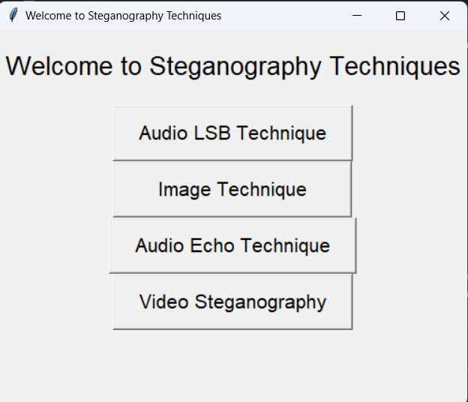

Fig 5 .1

5.1 LSB Technique on Images:

Using the UI, several experiments were conducted to apply the LSB technique on images and hide secret data within them. Users could select a cover image and a secret data message using the input dialogs provided by the UI. After embedding the data, the modified image and the original image were displayed side by side for visual comparison. Figure 1 shows an example of the original image, and Figure 2 displays the corresponding stego-image.

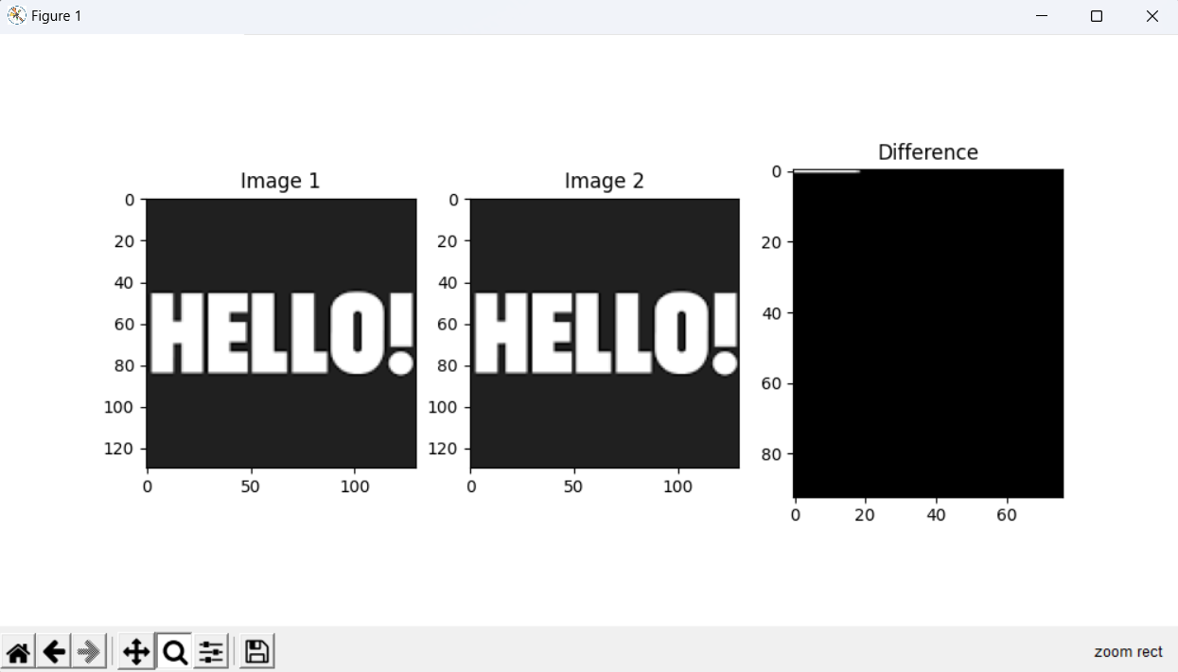

Fig 5.2

The visual comparison allowed users to observe the subtle differences introduced by the LSB embedding process, such as changes in pixel or modifications in specific image regions.

5.2 LSB Technique on Audio:

Similarly, the LSB technique was applied to audio files using the UI. Users could select an audio file as the cover media and a secret data message to be embedded. The UI displayed the spectrogram and waveform of both the original audio and the steganographic audio for comparison. Figure 5.3 represents the spectrogram of the original audio and steganographic audio.

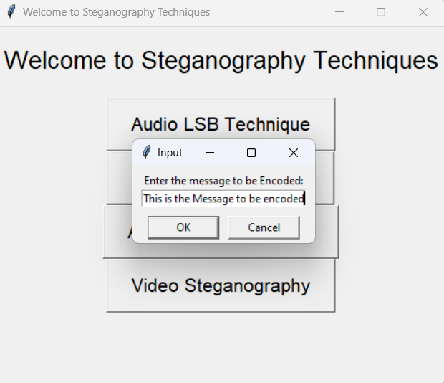

Fig 5.3

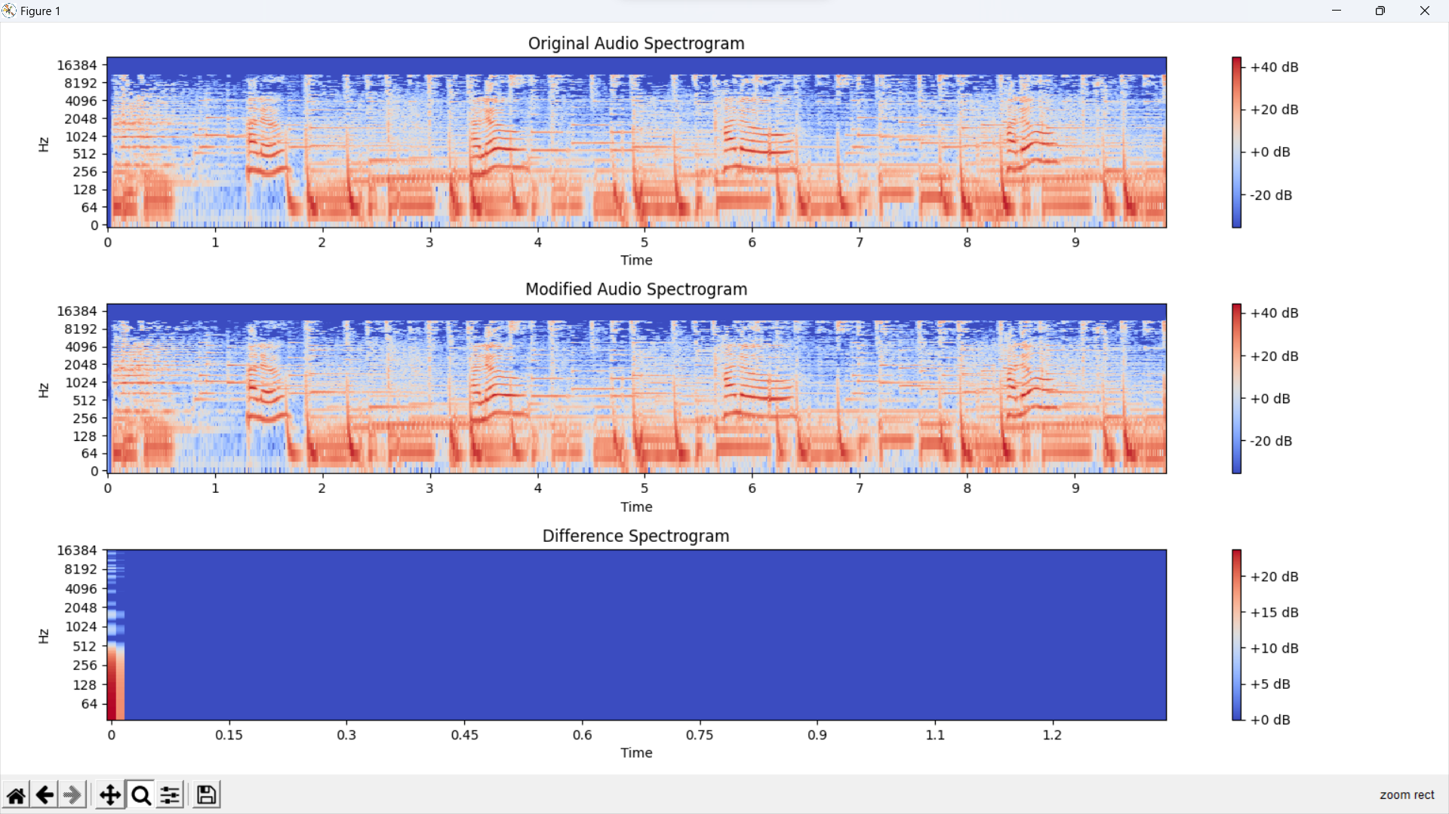

Fig 5.4

These visual representations allowed users to observe any changes or artifacts introduced by the LSB embedding process, such as variations in frequency components or distortions in the audio waveform.S

V. FUTURE SCOPE

The analysis of different steganography techniques presented in this research opens up several future directions for improvement:

6.1 Advanced Algorithms:

Further research can focus on developing advanced steganography algorithms with increased embedding capacity, improved security, and robustness against detection. This can involve exploring adaptive embedding algorithms, error correction coding, and encryption-based techniques.

6.2 Hybrid Approaches

Integration of multiple steganography techniques can lead to hybrid approaches that leverage the strengths of different methods. Combining LSB techniques with transform domain techniques or cascading multiple embedding algorithms can enhance overall performance and security.

6.3 Multimedia Steganography:

Expanding the analysis to include other multimedia formats like video and text can provide a comprehensive understanding of steganography techniques across different media types. Exploring steganography in emerging technologies such as virtual reality (VR) and augmented reality (AR) presents exciting opportunities.

6.4 Robustness and Security Analysis:

Future research can focus on evaluating the robustness and security of steganography techniques against various attacks, including statistical analysis, machine learning-based detection, and forensic analysis. Developing countermeasures to enhance resilience and assessing vulnerabilities can improve overall system security.

6.5 Steganalysis Techniques:

### Exploring steganalysis techniques and developing effective detection methods can aid in identifying hidden information within media files. This research area contributes to the field by enhancing the ability to detect steganography and uncover concealed data.

### These future directions hold promise for advancing steganography techniques, improving their performance, and addressing emerging challenges in data hiding and security.

### VI. CONCLUSION

In conclusion, this research paper explored different steganography techniques, including LSB on audio, image, and video, transform domain on images, and echo on audio. The analysis revealed the strengths and limitations of each technique. The LSB technique offered high embedding capacity but low robustness. The transform domain technique provided better visual imperceptibility but lower capacity. The echo technique showed promise in audio steganography with detection challenges. The developed user interface (UI) improved user interaction, allowing for media file selection, parameter adjustment, and result visualization. Graphical figures aided in understanding the impact of steganography techniques.

# VII. REFERENCES

1. Johnson, N. F., & Jajodia, S. (2019). Comparative analysis of LSB-based audio steganography techniques. Journal of Information Security and Applications, 46, 92-103. DOI: 10.1016/j.jisa.2019.04.003
2. Chang, C. C., et al. (2020). A pixel prediction-based least significant bit audio steganographic technique with improved quality. IEEE Access, 8, 122244-122255. DOI: 10.1109/ACCESS.2020.3003786
3. Raj, N. S., & Pillai, S. M. (2021). Comparative study of LSB technique in video steganography using different video compression algorithms. International Journal of Advanced Science and Technology, 30(5), 4557-4565. DOI: 10.14257/ijast.2021.30.05.417
4. Li, H., & Wang, B. (2018). Image steganography based on DCT coefficients and adaptive quantization. Multimedia Tools and Applications, 77(20), 26853-26868. DOI: 10.1007/s11042-018-6900-2
5. "A Survey on Image Steganography Techniques"

Authors: Kumar, P., & Meena, R. Journal: International Journal of Computer Applications DOI: 10.5120/ijca2015908289

1. "Echo Based Steganography in Audio Signals: A Survey" Authors: Kumar, A., & Kaur, K.

Journal: International Journal of Computer Science and Mobile Computing

DOI: 10.20533/ijcsmc.2017.006